Welcome to the Learning Center
The Learning Center provides one location for all employees to access online learning anytime, anywhere. You can monitor your personal progress and success that will help drive you toward your career aspirations.
GETTING STARTED
Access the Learning Center
From Internet Explorer, enter the following URL in your Internet browser:
Test your System  Click System Test on the login page to test your computer and ensure you have all the required programs installed to be able to login and use the Learning Center. Follow the links provided to upload more current versions of software if needed. | 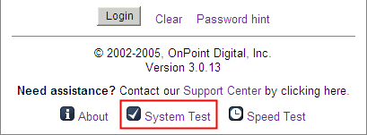
Login  Enter your Login ID and Password. Click the Login button. Note: Both fields are case sensitive.  After logging in, the Learning Center Portal Page will display. You may change your password by clicking on the My Profile link at the top right. | 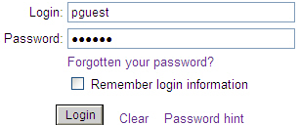
Main Portal Page  The Learning Center Portal allows you to:  - View important Messages.  - Access Learning Resources and make use of several Quick Links.  - Perform a Search to locate information that you need.  - Access your personalized Learning Path, Online Courses, Instructor-Led Events, On-the-Job Activities and view your Current Status.  - Take a shortcut to any Pending Assignments.  Tip: The Learning Center uses pop-up windows in various places to display new information. If you encounter an error reading “Pop-up blocked,” you will need to change your computer setup to allow pop-ups. | 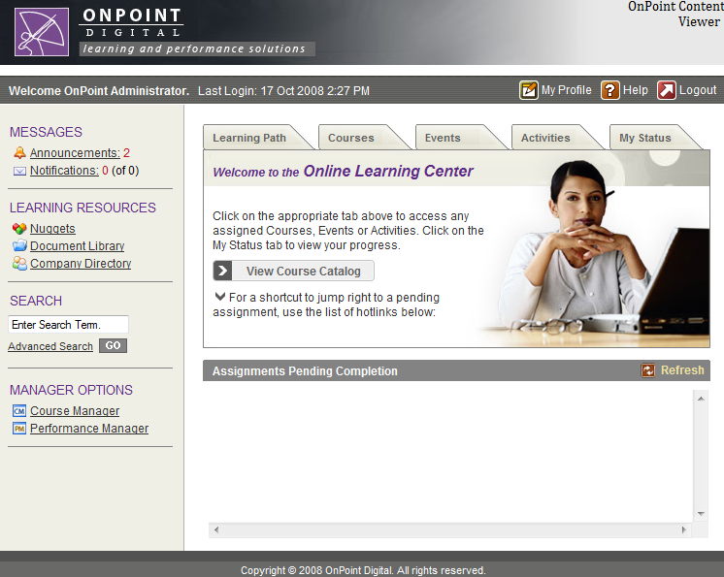

LEARNING CENTER REFERENCE AREA
Messages  Click Announcements to review information that is general in nature and distributed to a group of people from a specific person.  Click Notifications to review information sent by the system to you specifically, to remind you of any upcoming deadlines. | 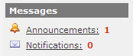
Learning Resources  Click Learning Nuggets to access information that is short and quick for you to review.  Click Reference Materials to access the Learning Center’s Document Library. The Library contains information such as training related materials and articles about learning. | 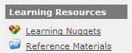
Search  Enter a word or phase into the Search field and press GO to find specific information that you would like to access.  Click Advanced Search to further refine your search results. | 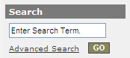
Manager Options  If you are a manager, you will see one or more Manager Options, depending on your role. Click the management options link to launch your selection in a new window.  Please refer to the Manager Start Guide for additional information. | 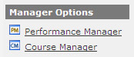

LEARNING CENTER ASSIGNMENTS AREA
Learning Path  Click the Learning Path tab to review your personalized Learning Path. This includes all items that have been assigned to you based on your current job role. The Learning Path lists all your assignments in the order in which they should be completed.  Click the name of any item to view and/or start the task. | 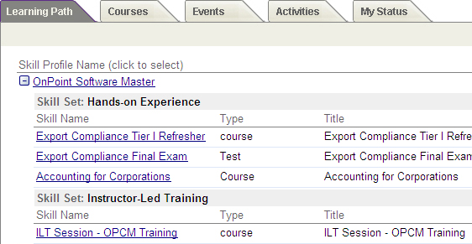
Courses  Click the Courses tab to view any online learning courses you are currently assigned to complete. When you select a course, a Course Information Screen will appear providing more details.  Click Start to start a course. Click Continue to continue a course that you have previously started. Click Browse to revisit a course you have previously completed. If you did not pass a final test of a course, click the Retake button to begin the course again. | 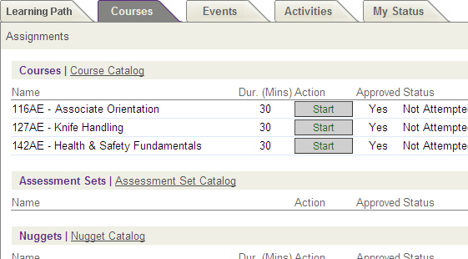
Course Navigation
Use the Arrows in the upper right corner of the screen to advance through the pages of the course until you have completed it. Use the “Go to” Dropdown to jump to different pages in the course whenever you are in Browse mode. Note: there may be other navigation arrows within a course page.
Use the Refresh icon to re-start any flash, video or audio clip, or re-load any page.
Tests  When you are taking a test, click the answer box or radio button next to the answer you wish to select.  When you have completed the test, click the Finish Test button at the bottom of the page. The system will grade and score your test.  Note: Some courses include in-course quizzes which may or may not be graded and/or recorded. | 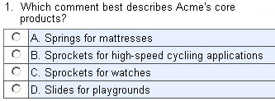
Locating a Course, Assessment or Nugget  Click Course Catalog to browse through all the online courses that are currently being offered.  In addition to courses, this tab includes a list of any standalone Assessments that have been assigned to you, for instance, a Survey or Feedback Form. Click Assessment Set Catalog to browse through all the available assessments.  Also listed on this tab are any assigned Nuggets. Click Nugget Catalog to browse through all available nuggets. | 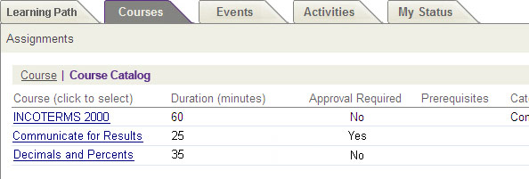
Events  Click the Events tab to view any classroom training events that you are currently assigned to attend, or to determine if you have been approved for any event where you submitted a request to attend.  Notice that you may view your assignments in a calendar view, or switch to a “list” view by changing the Display. Hover over any assignment for more detail.  Click Event Catalog at the top left to view all classroom training events that are currently being offered. | 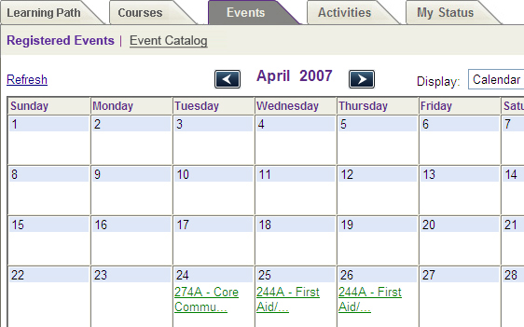
Activities  Click the Activities tab to view any on-the-job activities that have been assigned to you. An activity can include but is not limited to: reading a workbook, manual or policy, doing on-the-job shadowing or having a discussion with your manager.  Choose Pending, Not Completed or Completed to change the types of activities that are being displayed. | 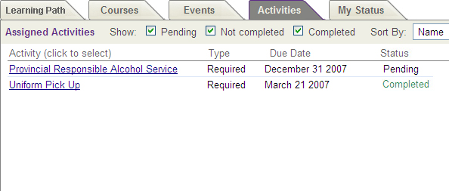
My Status  Click the My Status tab to view your Assignment Status in detail, including all courses, classroom events, on-the-job activities or nuggets assigned to you, and their associated completion status.  Click Competency Matrix to view the same information, organized by Learning Path/Skill Profile assignment.  Tip: There are a number of screens that display “Completion Status.” Different conditions govern the status of different types of items. For instance:  - Course “Incomplete” status can be caused by (1) insufficient time spent in the course, (2) failure to view each page of the course, or (3) failed score of an associated test  - Event “Incomplete” status can be caused by a user being assigned to a classroom training session, the event date has passed, and the instructor has not updated the class attendance record  - Activity “Pending” status will display until an administrator has approved your Activity as completed | 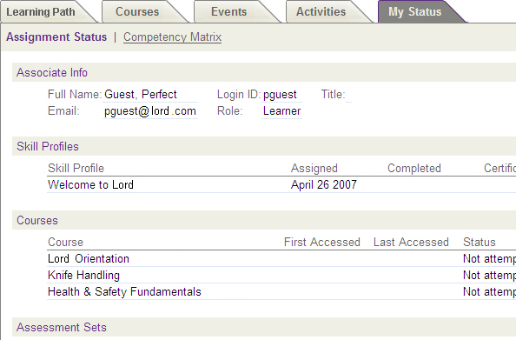

LEARNING CENTER ASSIGNMENTS SHORT-CUTS
Current Assignments-Pending Completion  The Current Assignments area, halfway down the screen, displays all of your assignments, categorized by type, that are still pending completion.  Click the name of the item to review its description and start the course, assessment, event, or activity. | 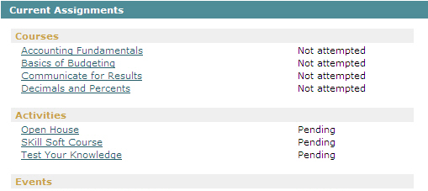

FINISH AND LOGOUT
Logout  When you are finished using any tabbed area of the Learning Center, click the Close icon to return to the main Portal page.  When you are finished using the Learning Center, click the Logout icon in the upper right corner. The system will ask if you are sure. Click the OK button to end your session. | 