The Performance Manager application provides an easy-to-use yet powerful online tool to view your User’s records and progress towards assigned Learning Paths, Courses, Nuggets, Events and Activities. You can also view test results and run reports on any users who are members of any groups you manage.
GETTING STARTED
Access
From IE, access the Learning Center portal by typing the following URL:
Login  To Login, enter your Login ID and password, and click the Login button.  Click the Performance Manager link on the lower left of the portal page to access the Performance Manager application. |  | 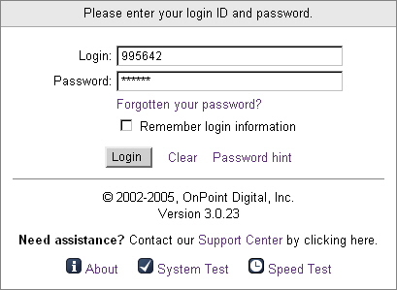
PERFORMANCE MANAGER TABS
Home  The Home Page displays your login role and the Company Message. From the Home Page you can click Home, Users, Appraisals or Reports. |  | 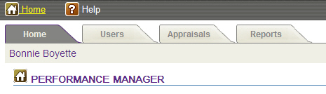
Users  The Performance Manager interface allows you as a Manager to view the assignments and status of any user that is a member of a group you manage.  Click the User’s tab and locate the user you want to review using the A-Z filter. Choose the first letter of the User’s last name to narrow your search.  Once you have selected a User, five sub-tabs will appear.  User Information contains the User’s contact details. This tab also allows you to display an Assignment Status and Competency Matrix.  Assignments shows what the User has been assigned to, including which Groups they are members of and what their job code is. It also shows what they are assigned to complete, including Courses, Assessments, Events, Activities, and Skill Profiles.  Test scores shows all the User’s test scores.  History displays any completed assignments that have been archived.  Mobile Profile shows the User’s mobile information, including any detail available regarding cell phones, smartphones, PDA’s, or Handtop devices they may use. This area will only be populated if the User has provided this information. |  | 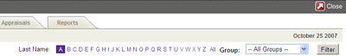  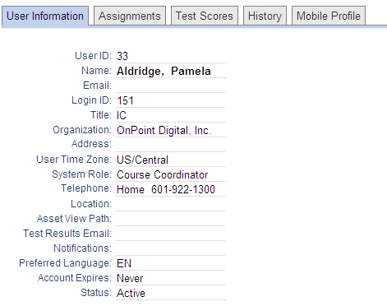
Appraisals  You can review any Sign-offs, Appraisals, or Reviews of performance, progress or completion of a user’s assignment. These actions are confidential; they are recorded in the user’s record, but are not typically viewable by them.  To begin, simply click the name of the assessment you wish to complete for a User. Assessments are organized by Category; use the Filter button in the upper right to narrow the list of choices.  Next, click the first letter of the last name of the User you would like to review. To further narrow your search, click Filter and enter the person’s last name.  Select the User that you want to review.  Complete the Assessment, just as you would complete any online test within the Online Learning Center. Click the Finish Test button at the bottom when you are finished. |  |  |  | 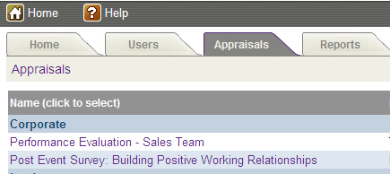
Reports
The Reports Tab provides a list of reports you can run for your groups.  - Click any of the report links listed.  - Choose any filters such as a date range for your report.  - Click the Generate Report Button to run the report.  Reports can be viewed onscreen, printed, or saved to a PDF or Excel file  format using the report icons at the top left. |  |  | 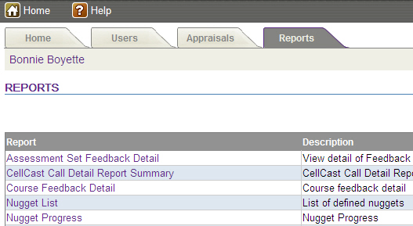
LOGOUT AND RETURN TO PORTAL
When you are finished using the Performance Manager, click the Close icon.
The system will ask you if you are sure. Click the OK button to return to the Learning Center Portal.

